**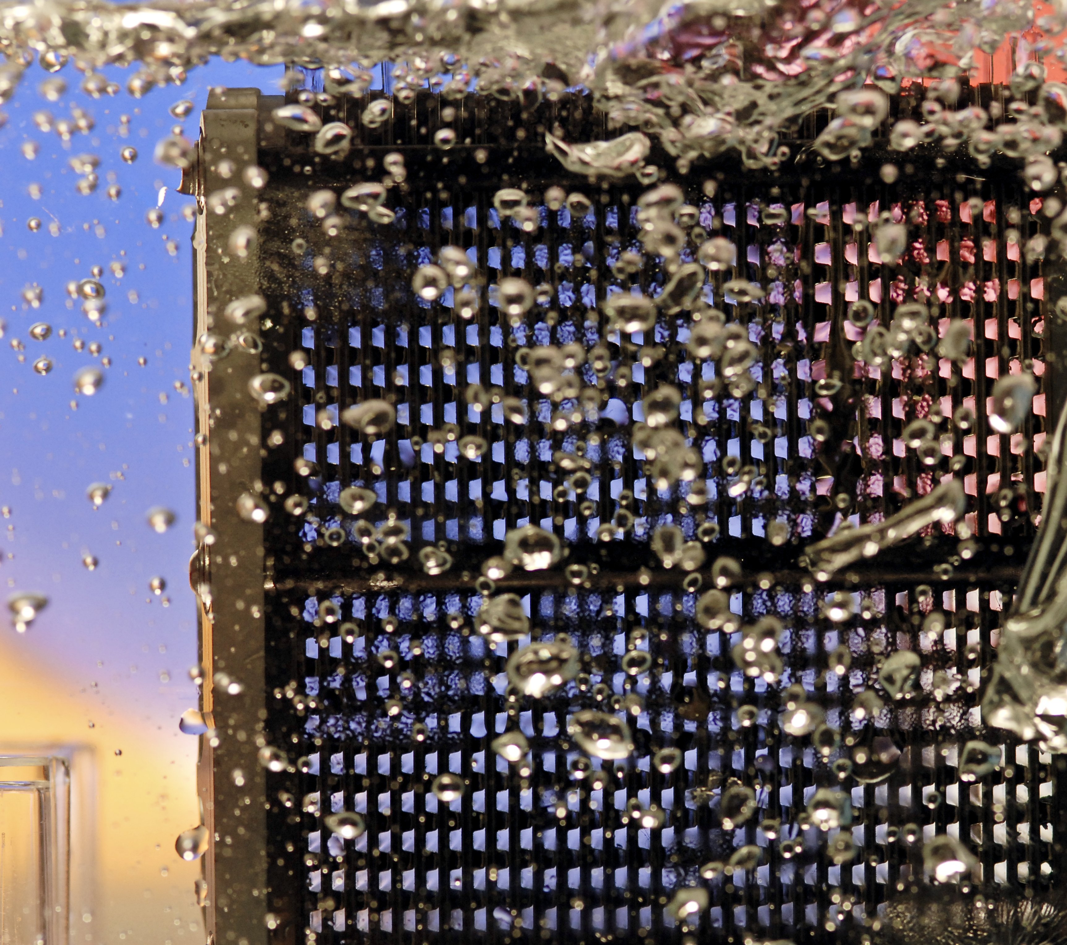**

|  |
| --- |
| FUEL CELL INDUSTRY ANALYSIS REPORT |
| 01/01/2015 |

Bambu, the team

|  |  |
| --- | --- |
| C:\Users\Konstantin Neumann\Documents\01_Dokumente & Daten 2015\CV\pictures\picture.jpg | ****Benoit Serot****  Lorem ipsum dolor sit amet, consectetuer adipiscing elit. Nam nibh. Nunc varius facilisis eros. Sed erat. In in velit quis arcu ornare laoreet. Curabitur adipiscing luctus massa. Integer ut purus ac augue commodo commodo. Nunc nec mi eu justo tempor consectetuer |
|  |  |
| C:\Users\Konstantin Neumann\Documents\01_Dokumente & Daten 2015\CV\pictures\picture.jpg | **Pongsathorn Tiranun**  Lorem ipsum dolor sit amet, consectetuer adipiscing elit. Nam nibh. Nunc varius facilisis eros. Sed erat. In in velit quis arcu ornare laoreet. Curabitur adipiscing luctus massa. Integer ut purus ac augue commodo commodo. Nunc nec mi eu justo tempor consectetuer |
|  |  |
| C:\Users\Konstantin Neumann\Documents\01_Dokumente & Daten 2015\CV\pictures\picture.jpg | **Konstantin Neumann**  Lorem ipsum dolor sit amet, consectetuer adipiscing elit. Nam nibh. Nunc varius facilisis eros. Sed erat. In in velit quis arcu ornare laoreet. Curabitur adipiscing luctus massa. Integer ut purus ac augue commodo commodo. Nunc nec mi eu justo tempor consectetuer |
|  |  |
| C:\Users\Konstantin Neumann\Documents\01_Dokumente & Daten 2015\CV\pictures\picture.jpg | **Shouka Arabi**  Lorem ipsum dolor sit amet, consectetuer adipiscing elit. Nam nibh. Nunc varius facilisis eros. Sed erat. In in velit quis arcu ornare laoreet. Curabitur adipiscing luctus massa. Integer ut purus ac augue commodo commodo. Nunc nec mi eu justo tempor consectetuer |

Table of contents

[Part 1: Introduction 3](#_Toc417860537)

[1.1 Intentions 3](#_Toc417860538)

[1.2 History of fuel cells 4](#_Toc417860539)

[1.3 Fuel cell as an alternative 4](#_Toc417860540)

[1.4 Short industry overview 4](#_Toc417860541)

[Part 2: Product description Error! Bookmark not defined.](#_Toc417860542)

[2.1 Introduction 5](#_Toc417860543)

[2.2 Technologies 6](#_Toc417860544)

[2.3 Applications 6](#_Toc417860545)

[2.4 Infrastructure 7](#_Toc417860546)

[Part 3: Future perspectives 9](#_Toc417860547)

[3.1 Opportunities 17](#_Toc417860548)

[3.2 Limitations and risks 18](#_Toc417860549)

[3.3 Forecast 18](#_Toc417860550)

[Part 4: Conclusion 20](#_Toc417860551)

[Part 5: Appendix 22](#_Toc417860552)

[5.1 Detailed table of contents 22](#_Toc417860553)

[5.2 Table of figures 23](#_Toc417860554)

[5.3 References 23](#_Toc417860555)

# Introduction

## Intentions

This report wants to inform about the state of the fuel cell industry. It wants to address a vast group of people, those who are in contact with fuel cells for the first time as well as those who already have a profound expertise in this field. Therefore the report gives a short introduction of history and also explains the different types and working mechanisms of fuel cells but also shows threads and chances by linking the gathered knowledge with new topics like blockchain.

The underlying informations for this report was gathered by a broad literature and internet research. Knowledge from previous Industry Reports as well as research paper, newspapers and press releases were used to show a broad spectrum of facts.

## History of fuel cells

The beginnings of fuel cells reach back to 1838. At this time William Robert Grove worked on what was later called fuel cell. Grove, who is credited with the invention of the fuel cell, used platinum together with hydrogen and oxygen to create a constant current. Several scientists including Christian Schönbein tried to show how exactly fuel cells are working. Although great discussions and large efforts it took several years to explain the system fully. In the early years there no practical device emerged. In the early 20th century the first molten carbonate fuel cell was built by Emil Baur. Further investigations were made by Francis Thomas Bacon who developed first fuel cells with a practical use. His work was promising enough to be licensed by Pratt & Whitney for the Apollo missions. From the 1960s the history is becoming more branched as the different technologies, develop different[[1]](#footnote-1). At General Electric Willard Thomas Grubb and Leonard Niedrach invented the first PEMFC which was later refined and used by NASA for the Gemini Mission in the 1960s. International fuel cells developed other systems for the Apollo missions. Also in the Soviet Union there was research in this field of technology, mainly for military purposes, later also for space missions. Driven by the oil crisis in the 1970s nearly all major car manufacturer had developed a FCEV. Another effect of the oil shortage was progress in the development of PAFC which are featuring higher possible outputs. Although high growth rates are predicted in the 1980s, there was just a slow adaption of the new technology. In the 1990s the focus was laid on small stationary applications[[2]](#footnote-2). Also the first battery of methanol was developed as a portable device. Another promising field is the public transport, especially buses, where first models where available around 2000. First applications for end users include auxiliary power units, e.g. for caravans. In the 2007 the first hydrogen car was presented, the Honda FCX Clarity, which is available for customers since 2008 for leasing. Since then many other models from different manufacturers are available. Residential fuel cells as well as micro devices, like phone chargers became more popular and available during the last years. Therefore the industry is changing from mainly R&D focused to commercialize products[[3]](#footnote-3)[[4]](#footnote-4).

PEMFC: proton exchange membrane fuel cell

FCEV: fuel cell electric vehicle

PAFC: phosphoric acid fuel cells

## Fuel cell as an alternative

Fuel cells can be used as a substitute as well as a complementing technology. The applications can be divided into the three categories stationary, transport and portable. The area of stationary fuel cells includes systems like plants or one household systems. In this area it is possible to complement for example regenerative energies with fuel cells to store the energy during the time it is not needed and by doing so building a smart network. As it is a clean and very fast reacting technology it can be also used in cities, for example instead of gas plants. Portable systems in different scales can be used for example as a supplement for diesel generator to support of grid systems with energy. Micro systems compete with traditional batteries. The transport sector is probably the most competitive area as fuel cells are in direct competition with traditional fuel as well as battery cars. Further discussion about these topic will be hold in part 5.

## Short industry overview

As pointed out in the history section above the fuel cell market for customer is quite young and therefore still shaping itself rapidly. On the market there are several big players as well as niche producers. In general big stationary systems (e.g. plants) are built by bigger companies whereas the portable systems are mostly distributed by smaller companies. The fuel cell market is strongly related to different regions, which was the reason to divide the analysis in three main regions.

# Product description

## Introduction

dapibus augue arcu eget arcu.

## Technologies

est. Vivamus ornare, felis et luctus dapibus, lacus leo convallis diam, eget dapibus augue arcu eget arcu.

### PEMFC

### AFC

### PAFC

### SOFC

### MCFC

### DMFC

### Summary

## Applications

Lorem ipsum dolor sit amet, consectetuer adipiscing elit. Nam nibh. Nunc varius facilisis eros. Sed erat. In in velit quis arcu ornare laoreet. Curabitur adipiscing luctus massa. Integer ut purus ac augue commodo commodo. dolor. Aliquam vel magna non nunc ornare bibendum. Sed libero. Maecenas at est. Vivamus ornare, felis et luctus dapibus, lacus leo convallis diam, eget dapibus augue arcu eget arcu.

### Categorisation choices

### Transport

### Portable

### Stationary

## Infrastructure

Lorem ipsum dolor sit amet, consectetuer adipiscing elit. Nam nibh. Nunc at est. Vivamus ornare, felis et luctus dapibus, lacus leo convallis diam, eget dapibus augue arcu eget arcu.

### Distribution facilities

#### Delivery

#### Hydrogen storage

### Hydrogen production

#### Introduction

#### Electrolysis

#### Steam reforming

#### Summary

# Market Perspective

## Introduction

Lorem ipsum dolor sit amet, consectetuer adipiscing elit. Nam nibh. Nunc dapibus augue arcu eget arcu.

## Investment Cost Reduction

Lorem ipsum dolor sit amet, consectetuer adipiscing elit. Nam nibh. Nunc varius facilisis eros. Sed erat. In in velit quis arcu ornare laoreet. Curabitur sem at nisi laoreet placerat. Duis sed ipsum ac nibh mattis feugiat. Proin sed purus. Vivamus lectus ipsum, rhoncus sed, scelerisque sit amet, ultrices in, dolor. Aliquam vel magna non nunc ornare bibendum. Sed libero. Maecenas at est. Vivamus ornare, felis et luctus dapibus, lacus leo convallis diam, eget dapibus augue arcu eget arcu.

## Research and Development Fundings

Lorem ipsum dolor sit amet, consectetuer adipiscing elit. Nam nibh. Nunc varius facilisis eros. Sed erat. In in velit quis arcu ornare laoreet. Curabitur adipiscing luctus massa. Integer ut purus ac augue commodo commodo. Nunc nec mi eu justo tempor consectetuer. Etiam vitae nisl. In dignissim lacus ut ante. Cras elit lectus, bibendum a, adipiscing vitae, commodo et, dui. Ut tincidunt tortor. Donec nonummy, enim in lacinia pulvinar, velit tellus sem at nisi laoreet placerat. Duis sed ipsum ac nibh mattis feugiat. Proin sed purus. Vivamus lectus ipsum, rhoncus sed, scelerisque sit amet, ultrices in, dolor. Aliquam vel magna non nunc ornare bibendum. Sed libero. Maecenas at est. Vivamus ornare, felis et luctus dapibus, lacus leo convallis diam, eget dapibus augue arcu eget arcu.

## Top Investors

## Quantity of Fuel Cells shipped

## Hydrogen Refuelling Stations

## Major Companies

### Public Companies

### Private Companies

# Law and governmental regulations

## Forms of influence

Lorem ipsum dolor sit amet, consectetuer adipiscing elit. Nam nibh. Nunc varius facilisis eros. Sed erat. In in velit quis arcu ornare laoreet. Curabitur adipiscing luctus massa. Integer ut purus ac augue commodo commodo.

dapibus augue arcu eget arcu.

## Situation in Germany

## Situation in the USA

# Comparison to other technologies

## Alternative technologies

Lorem ipsum dolor sit amet, consectetuer adipiscing elit. Nam nibh. Nunc varius facilisis eros. Sed erat. In in velit quis arcu ornare laoreet. Curabitur adipiscing luctus massa. Integer ut purus ac augue commodo commodo. Nunc nec mi eu justo tempor consectetuer. Etiam vitae nisl. In dignissim sem at nisi laoreet placerat. Duis sed ipsum ac nibh mattis feugiat. Proin sed purus. Vivamus lectus ipsum, rhoncus sed, scelerisque sit amet, ultrices in, dolor. Aliquam vel magna non nunc ornare bibendum. Sed libero. Maecenas at est. Vivamus ornare, felis et luctus dapibus, lacus leo convallis diam, eget dapibus augue arcu eget arcu.

### Introduction about different technologies

### Trend of these technologies in different regions

## Advantages and disadvantages of fuel cells

Lorem ipsum dolor sit amet, consectetuer adipiscing elit. Nam nibh. Nunc varius facilisis eros. Sed erat. In in velit quis arcu ornare laoreet. Curabitur adipiscing luctus massa. Integer ut purus ac augue commodo commodo. Nunc nec mi eu justo tempor consectetuer. Etiam vitae nisl. In dignissim lacus ut ante. Cras elit lectus, bibendum a, adipiscing vitae, commodo et, dui. Ut tincidunt tortor. Donec nonummy, enim in lacinia pulvinar, velit tellus scelerisque augue, ac posuere libero urna eget neque. Cras ipsum. sem at nisi laoreet placerat. Duis sed ipsum ac nibh mattis feugiat. Proin sed purus. Vivamus lectus ipsum, rhoncus sed, scelerisque sit amet, ultrices in, dolor. Aliquam vel magna non nunc ornare bibendum. Sed libero. Maecenas at est. Vivamus ornare, felis et luctus dapibus, lacus leo convallis diam, eget dapibus augue arcu eget arcu.

### Advantages

### Disadvantages

### Challenges

## Different elements of settling a technology

Lorem ipsum dolor sit amet, consectetuer adipiscing elit. Nam nibh. Nunc varius facilisis eros. Sed erat. In in velit quis arcu ornare laoreet. Curabitur adipiscing luctus massa. Integer ut purus ac augue commodo commodo. Nunc nec mi eu justo tempor consectetuer. Etiam vitae nisl. In dignissim at est. Vivamus ornare, felis et luctus dapibus, lacus leo convallis diam, eget dapibus augue arcu eget arcu.

### alternative elements

### policy as an important element

# Future perspectives

## Opportunities

Lorem ipsum dolor sit amet, consectetuer adipiscing elit. Nam nibh. Nunc varius facilisis eros. Sed erat. In in velit quis arcu ornare laoreet. Curabitur adipiscing luctus massa. Integer ut purus ac augue commodo commodo. dapibus augue arcu eget arcu.

## Limitations and risks

Lorem ipsum dolor sit amet, consectetuer adipiscing elit. Nam nibh. Nunc varius facilisis eros. Sed erat. In in velit quis arcu ornare laoreet. Curabitur sem at nisi laoreet placerat. Duis sed ipsum ac nibh mattis feugiat. Proin sed purus. Vivamus lectus ipsum, rhoncus sed, scelerisque sit amet, ultrices in, dolor. Aliquam vel magna non nunc ornare bibendum. Sed libero. Maecenas at est. Vivamus ornare, felis et luctus dapibus, lacus leo convallis diam, eget dapibus augue arcu eget arcu.

## Forecast

Lorem ipsum dolor sit amet, consectetuer adipiscing elit. Nam nibh. Nunc varius facilisis eros. Sed erat. In in velit quis arcu ornare laoreet. Curabitur adipiscing luctus massa. Integer ut purus ac augue commodo commodo. Nunc nec mi eu justo tempor consectetuer. Etiam vitae nisl. In dignissim lacus ut ante. Cras elit lectus, bibendum a, adipiscing vitae, commodo et, dui. Ut tincidunt tortor. Donec nonummy, enim in lacinia pulvinar, velit tellus scelerisque augue, ac posuere libero urna eget neque. Cras ipsum. at est. Vivamus ornare, felis et luctus dapibus, lacus leo convallis diam, eget dapibus augue arcu eget arcu.

# Conclusion

Lorem ipsum dolor sit amet, consectetuer adipiscing elit. Nam nibh. Nunc varius facilisis eros. Sed erat. In in velit quis arcu ornare laoreet. Curabitur sem at nisi laoreet placerat. Duis sed ipsum ac nibh mattis feugiat. Proin sed purus. Vivamus lectus ipsum, rhoncus sed, scelerisque sit amet, ultrices in, dolor. Aliquam vel magna non nunc ornare bibendum. Sed libero. Maecenas at est. Vivamus ornare, felis et luctus dapibus, lacus leo convallis diam, eget dapibus augue arcu eget arcu.

# Appendix

## Detailed table of contents

[1 Introduction 3](#_Toc417579162)

[1.1 Intentions 3](#_Toc417579163)

[1.2 History of fuel cells 4](#_Toc417579164)

[1.3 Fuel cell as an alternative 4](#_Toc417579165)

[1.4 Short industry overview 4](#_Toc417579166)

[2 Product description Error! Bookmark not defined.](#_Toc417579167)

[2.1 Introduction 5](#_Toc417579168)

[2.2 Technologies 6](#_Toc417579169)

[2.3 Applications 6](#_Toc417579170)

[2.4 Infrastructures **Error! Bookmark not defined.**](#_Toc417579171)

[3 Market perspectives Error! Bookmark not defined.](#_Toc417579172)

[3.1 "2014" Market status by application **Error! Bookmark not defined.**](#_Toc417579173)

[3.2 "2014" Unit shipments by fuel cell types **Error! Bookmark not defined.**](#_Toc417579174)

[3.3 Regional Focus **Error! Bookmark not defined.**](#_Toc417579175)

[4 Law and governmental regulations Error! Bookmark not defined.](#_Toc417579176)

[4.1 Forms of influence **Error! Bookmark not defined.**](#_Toc417579177)

[4.2 Situation in Japan **Error! Bookmark not defined.**](#_Toc417579178)

[4.3 Situation in Germany **Error! Bookmark not defined.**](#_Toc417579179)

[4.4 Situation in the U.S.A. **Error! Bookmark not defined.**](#_Toc417579180)

[5 Comparison to other technologies Error! Bookmark not defined.](#_Toc417579181)

[5.1 Novel technologies **Error! Bookmark not defined.**](#_Toc417579182)

[5.2 The rate of power suppliers in different regions **Error! Bookmark not defined.**](#_Toc417579183)

[5.3 Main areas of competition **Error! Bookmark not defined.**](#_Toc417579184)

[5.4 Advantages and disadvantages **Error! Bookmark not defined.**](#_Toc417579185)

[6 Future perspectives 9](#_Toc417579186)

[6.1 Opportunities 17](#_Toc417579187)

[6.2 Limitations and risks 18](#_Toc417579188)

[6.3 Forecast 18](#_Toc417579189)

[7 Conclusion 20](#_Toc417579190)

[8 Appendix 22](#_Toc417579191)

[8.1 Detailed table of contents 22](#_Toc417579192)

[8.2 Table of figures 23](#_Toc417579193)

[8.3 References 23](#_Toc417579194)

## Table of figures

Bibliography

Andújar, J. M., and F. Segura. “Fuel cells: History and updating. A walk along two centuries.” *Renewable and Sustainable Energy Reviews* 13, no. 9 (2009): 2309–22. doi:10.1016/j.rser.2009.03.015. http://www.sciencedirect.com/science/article/pii/S1364032109001336.

“Fuel Cell History - Fuel Cell Today.” Accessed May 6, 2015. http://www.fuelcelltoday.com/history.

“Fuel Cells: Discovering the Science.” Accessed May 13, 2015. http://americanhistory.si.edu/fuelcells/origins/origins.htm.

1. “Fuel Cells: Discovering the Science,” accessed May 13, 2015, http://americanhistory.si.edu/fuelcells/origins/origins.htm [↑](#footnote-ref-1)
2. “Fuel Cell History - Fuel Cell Today,” accessed May 6, 2015, http://www.fuelcelltoday.com/history [↑](#footnote-ref-2)
3. Ibid. [↑](#footnote-ref-3)
4. J. M. Andújar and F. Segura, “Fuel cells: History and updating. A walk along two centuries,” *Renewable and Sustainable Energy Reviews* 13, no. 9 (2009), doi:10.1016/j.rser.2009.03.015, http://www.sciencedirect.com/science/article/pii/S1364032109001336 [↑](#footnote-ref-4)